**PURPOSE OF THE SITE**

I have created this demo site using Angular 2 as client side language and CakePHP as server side language.

The site basically used to login (including social login) and sign-up into this site using Angular 2 system.

Following is the URL of this site :- <http://testyourprojects.biz/custom/test_sanchari/angular_2_login/>.

When anyone hit the URL in browser he/she will be able to see the login page (Image below):-

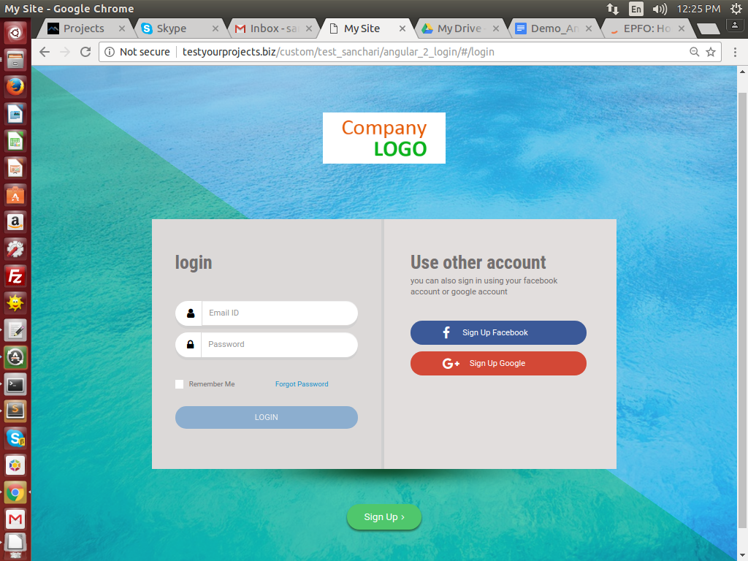

Users can able to login into the site with their credential. Validation is of this form is implemented as per Angular2 standard.

On clicking the ‘**Sign Up Facebook**’ button and ‘**Sign Up Google**’ button users are able to login into the site via their Facebook account and Google Account respectively.

By clicking ‘**Sign Up**’ link user will be able to sign up into the site. User will get a after successful sign up.

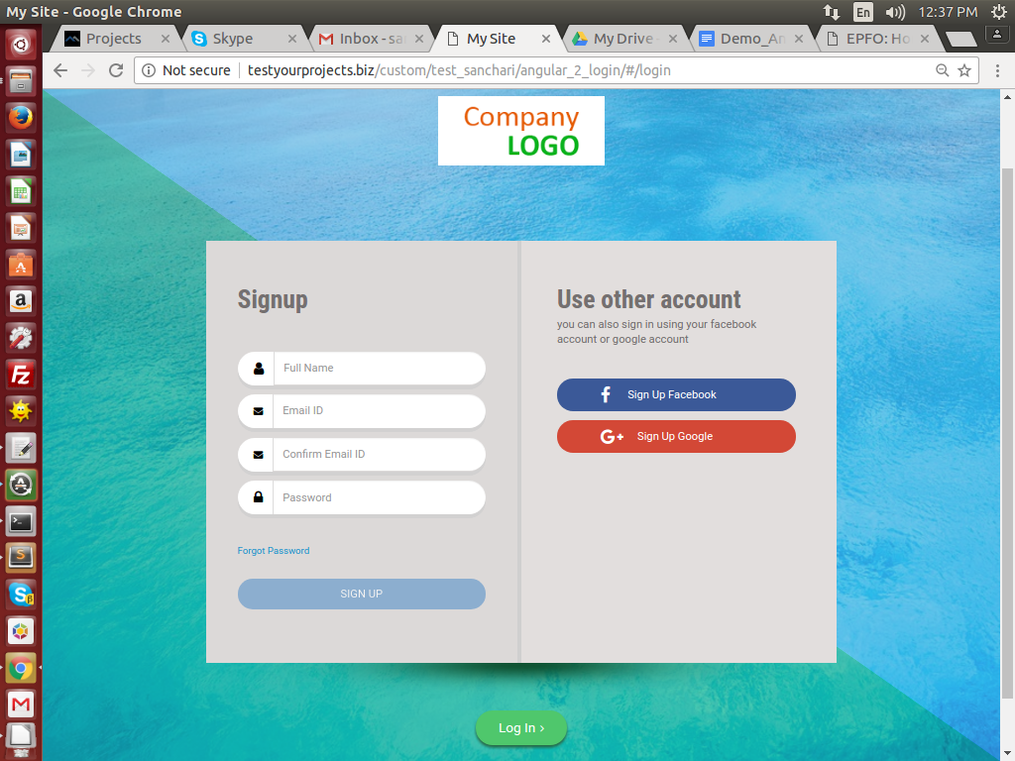

By clicking the ‘**Forgot Password**’ link user will be able to view the ‘Forgot Password’ form

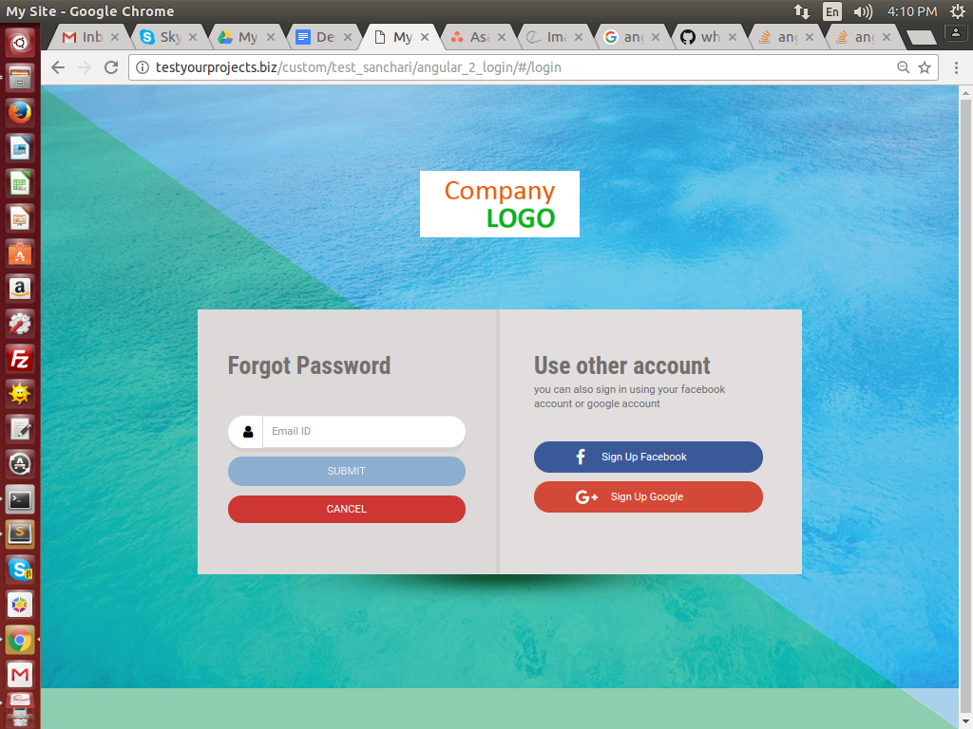

After a successful submission of ‘Forget Password’ form a mail will be sent to the corresponding email address, from where user can get the link of the reset password form for changing the password.

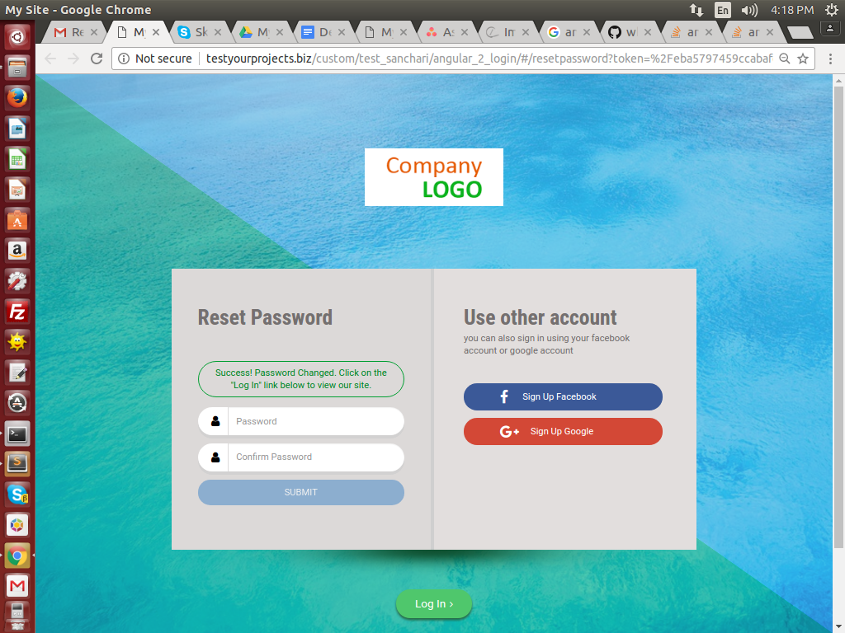

After successful login user can view a simple home page.

**CODING STRUCTURE OF THE SITE**

Angular 2 is used as a server side language here. The code module of Angular 2 for this site is attached in ‘**angular_2_login.zip**’ file.

To run angular 2 in any system locally one must need **npm and node** installed in his/her machine, then he/she should unzip the angular_2_login.zip folder and paste it in the work folder, after that he/she need to run the ‘**npm install**’ command **from command prompt** for that particular project folder.

To get the build and run the project in different server one must run the ‘**ng build**’ command in command prompt and copy - paste the build from ‘**dist**’ folder to his/her desired server folder where he/she wants to run the project.

( **Note** :- For login and social login purpose this project build must be placed in the server).

The server side coding is implemented in cakephp and is attached with the in ‘**server.zip**’ file.

**To run the complete project in server (as social login can not be done from local)**

Create a folder in server, then paste the angular-2 build in that folder, then create a folder named ‘**admin**’ in the folder and within the **admin** folder keep the server side code.   
  
You can see the folder structure in - **192.168.1.12/custom/test_sanchari/angular-2-login**

**DATABASE DETAILS**

URL :- <http://192.168.1.12/phpmyadmin/>

Username:- matrixadmin2016

Password:- MwL5sujTuEbLX3Ge

DB Name:- test_sanchari_angular2